Monitor Site Recovery with Azure Monitor Logs

Contents
Configure Site Recovery to send logs 2
Query the logs - examples 3
Query replication health 3
Query Mobility service version 3
Query RPO time 3
Query Site Recovery jobs 4
Query Site Recovery events 4
Query test failover state (pie chart) 4
Query test failover state (table) 4
Query machine RPO 5
Query data change rate (churn) for a A2A VM 5
Query disaster recovery summary (Azure to Azure) 5
Query disaster recovery summary (VMware/physical servers) 6
Set up alerts - examples 7
Multiple machines in a critical state 7
Single machine in a critical state 7
Multiple machines exceed RPO 7
Single machine exceeds RPO 8
Test failover for multiple machines exceeds 90 days 8
Test failover for single machine exceeds 90 days 8
Site Recovery job fails 9
Monitor and query churn and upload rate for VMware or physical machines 10

Configure Site Recovery to send logs
- In the vault, click Diagnostic settings > Add diagnostic setting.
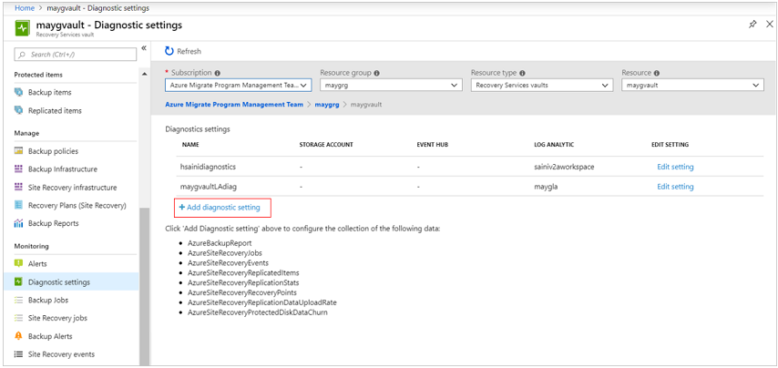
- In Diagnostic settings, specify a name for log action, and select Send to Log Analytics.
- Select the Azure Monitor Logs subscription, and the Log Analytics workspace.
- From the log list, select all the logs with the prefix AzureSiteRecovery. Then click OK.
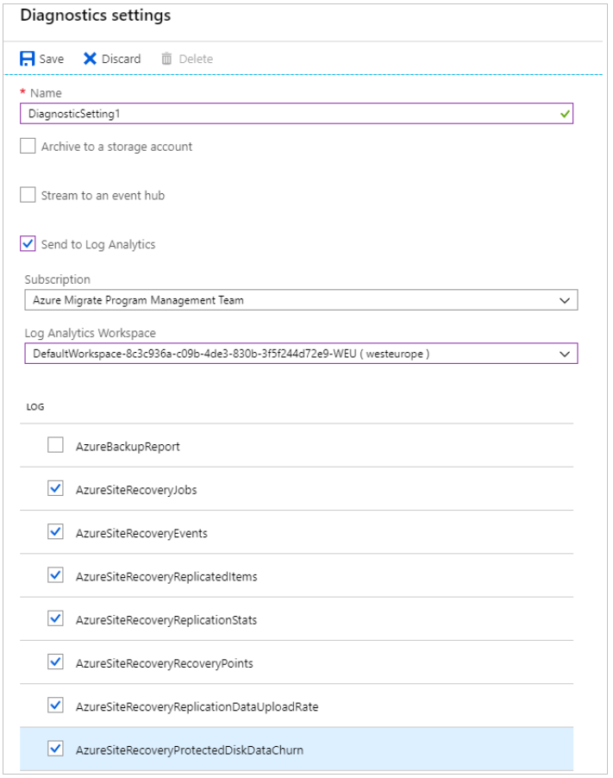
The Site Recovery logs start to feed into a table (AzureDiagnostics) in the selected workspace.

Query the logs - examples
You retrieve data from logs using log queries written with the Kusto query language. This section provides a few examples of common queries you might use for Site Recovery monitoring.
Note:
Some of the examples use replicationProviderName_s set to A2A. This retrieves Azure VMs that are replicated to a secondary Azure region using Site Recovery. In these examples, you can replace A2A with InMageAzureV2, if you want to retrieve on-premises VMware VMs or physical servers that are replicated to Azure using Site Recovery.

Query replication health
This query plots a pie chart for the current replication health of all protected Azure VMs, broken down into three states: Normal, Warning, or Critical.
AzureDiagnostics
| where replicationProviderName_s == "A2A"
| where isnotempty(name_s) and isnotnull(name_s)
| summarize hint.strategy=partitioned arg_max(TimeGenerated, *) by name_s
| project name_s , replicationHealth_s
| summarize count() by replicationHealth_s
| render piechart

Query Mobility service version
This query plots a pie chart for Azure VMs replicated with Site Recovery, broken down by the version of the Mobility agent that they're running.
AzureDiagnostics
| where replicationProviderName_s == "A2A"
| where isnotempty(name_s) and isnotnull(name_s)
| summarize hint.strategy=partitioned arg_max(TimeGenerated, *) by name_s
| project name_s , agentVersion_s
| summarize count() by agentVersion_s
| render piechart

Query RPO time
This query plots a bar chart of Azure VMs replicated with Site Recovery, broken down by recovery point objective (RPO): Less than 15 minutes, between 15-30 minutes, more than 30 minutes.
AzureDiagnostics
| where replicationProviderName_s == "A2A"
| where isnotempty(name_s) and isnotnull(name_s)
| extend RPO = case(rpoInSeconds_d <= 900, "<15Min",
rpoInSeconds_d <= 1800, "15-30Min", ">30Min")
| summarize hint.strategy=partitioned arg_max(TimeGenerated, *) by name_s
| project name_s , RPO
| summarize Count = count() by RPO
| render barchart

Query Site Recovery jobs
This query retrieves all Site Recovery jobs (for all disaster recovery scenarios), triggered in the last 72 hours, and their completion state.
AzureDiagnostics
| where Category == "AzureSiteRecoveryJobs"
| where TimeGenerated >= ago(72h)
| project JobName = OperationName , VaultName = Resource , TargetName = affectedResourceName_s, State = ResultType

Query Site Recovery events
This query retrieves all Site Recovery events (for all disaster recovery scenarios) raised in the last 72 hours, along with their severity.
AzureDiagnostics
| where Category == "AzureSiteRecoveryEvents"
| where TimeGenerated >= ago(72h)
| project AffectedObject=affectedResourceName_s , VaultName = Resource, Description_s = healthErrors_s , Severity = Level

Query test failover state (pie chart)
This query plots a pie chart for the test failover status of Azure VMs replicated with Site Recovery.
AzureDiagnostics
| where replicationProviderName_s == "A2A"
| where isnotempty(name_s) and isnotnull(name_s)
| where isnotempty(failoverHealth_s) and isnotnull(failoverHealth_s)
| summarize hint.strategy=partitioned arg_max(TimeGenerated, *) by name_s
| project name_s , Resource, failoverHealth_s
| summarize count() by failoverHealth_s
| render piechart

Query test failover state (table)
This query plots a table for the test failover status of Azure VMs replicated with Site Recovery.
AzureDiagnostics
| where replicationProviderName_s == "A2A"
| where isnotempty(name_s) and isnotnull(name_s)
| where isnotempty(failoverHealth_s) and isnotnull(failoverHealth_s)
| summarize hint.strategy=partitioned arg_max(TimeGenerated, *) by name_s
| project VirtualMachine = name_s , VaultName = Resource , TestFailoverStatus = failoverHealth_s

Query machine RPO
This query plots a trend graph that tracks the RPO of a specific Azure VM (ContosoVM123) for the last 72 hours.
AzureDiagnostics
| where replicationProviderName_s == "A2A"
| where TimeGenerated > ago(72h)
| where isnotempty(name_s) and isnotnull(name_s)
| where name_s == "ContosoVM123"
| project TimeGenerated, name_s , RPO_in_seconds = rpoInSeconds_d
| render timechart

Query data change rate (churn) for a A2A VM
This query plots a trend graph for a specific Azure VM (ContosoVM123), that tracks the data change rate (Write Bytes per Second), and data upload rate. This information is only available for Azure VMs replicated to a secondary Azure region.
AzureDiagnostics
| where Category in ("AzureSiteRecoveryProtectedDiskDataChurn", "AzureSiteRecoveryReplicationDataUploadRate")
| extend CategoryS = case(Category contains "Churn", "DataChurn",
Category contains "Upload", "UploadRate", "none")
| extend InstanceWithType=strcat(CategoryS, "_", InstanceName_s)
| where TimeGenerated > ago(24h)
| where InstanceName_s startswith "ContosoVM123"
| project TimeGenerated , InstanceWithType , Churn_MBps = todouble(Value_s)/1048576
| render timechart

Query disaster recovery summary (Azure to Azure)
This query plots a summary table for Azure VMs replicated to a secondary Azure region. It shows VM name, replication and protection status, RPO, test failover status, Mobility agent version, any active replication errors, and the source location.
AzureDiagnostics
| where replicationProviderName_s == "A2A"
| where isnotempty(name_s) and isnotnull(name_s)
| summarize hint.strategy=partitioned arg_max(TimeGenerated, *) by name_s
| project VirtualMachine = name_s , Vault = Resource , ReplicationHealth = replicationHealth_s, Status = protectionState_s, RPO_in_seconds = rpoInSeconds_d, TestFailoverStatus = failoverHealth_s, AgentVersion = agentVersion_s, ReplicationError = replicationHealthErrors_s, SourceLocation = primaryFabricName_s

Query disaster recovery summary (VMware/physical servers)
This query plots a summary table for VMware VMs and physical servers replicated to Azure. It shows machine name, replication and protection status, RPO, test failover status, Mobility agent version, any active replication errors, and the relevant process server.
AzureDiagnostics
| where replicationProviderName_s == "InMageAzureV2"
| where isnotempty(name_s) and isnotnull(name_s)
| summarize hint.strategy=partitioned arg_max(TimeGenerated, *) by name_s
| project VirtualMachine = name_s , Vault = Resource , ReplicationHealth = replicationHealth_s, Status = protectionState_s, RPO_in_seconds = rpoInSeconds_d, TestFailoverStatus = failoverHealth_s, AgentVersion = agentVersion_s, ReplicationError = replicationHealthErrors_s, ProcessServer = processServerName_g

Set up alerts - examples
You can set up Site Recovery alerts based on Azure Monitor data. Learn more about setting up log alerts.
Note
Some of the examples use replicationProviderName_s set to A2A. This sets alerts for Azure VMs that are replicated to a secondary Azure region. In these examples, you can replace A2A with InMageAzureV2 if you want to set alerts for on-premises VMware VMs or physical servers replicated to Azure.

Multiple machines in a critical state
Set up an alert if more than 20 replicated Azure VMs go into a Critical state.
AzureDiagnostics
| where replicationProviderName_s == "A2A"
| where replicationHealth_s == "Critical"
| where isnotempty(name_s) and isnotnull(name_s)
| summarize hint.strategy=partitioned arg_max(TimeGenerated, *) by name_s
| summarize count()
For the alert, set Threshold value to 20.

Single machine in a critical state
Set up an alert if a specific replicated Azure VM goes into a Critical state.
AzureDiagnostics
| where replicationProviderName_s == "A2A"
| where replicationHealth_s == "Critical"
| where name_s == "ContosoVM123"
| where isnotempty(name_s) and isnotnull(name_s)
| summarize hint.strategy=partitioned arg_max(TimeGenerated, *) by name_s
| summarize count()
For the alert, set Threshold value to 1.

Multiple machines exceed RPO
Set up an alert if the RPO for more than 20 Azure VMs exceeds 30 minutes.
AzureDiagnostics
| where replicationProviderName_s == "A2A"
| where isnotempty(name_s) and isnotnull(name_s)
| where rpoInSeconds_d > 1800
| summarize hint.strategy=partitioned arg_max(TimeGenerated, *) by name_s
| project name_s , rpoInSeconds_d
| summarize count()
For the alert, set Threshold value to 20.

Single machine exceeds RPO
Set up an alert if the RPO for a single Azure VM exceeds 30 minutes.
AzureDiagnostics
| where replicationProviderName_s == "A2A"
| where isnotempty(name_s) and isnotnull(name_s)
| where name_s == "ContosoVM123"
| where rpoInSeconds_d > 1800
| summarize hint.strategy=partitioned arg_max(TimeGenerated, *) by name_s
| project name_s , rpoInSeconds_d
| summarize count()
For the alert, set Threshold value to 1.

Test failover for multiple machines exceeds 90 days
Set up an alert if the last successful test failover was more than 90 days, for more than 20 VMs.
AzureDiagnostics
| where replicationProviderName_s == "A2A"
| where Category == "AzureSiteRecoveryReplicatedItems"
| where isnotempty(name_s) and isnotnull(name_s)
| where lastSuccessfulTestFailoverTime_t <= ago(90d)
| summarize hint.strategy=partitioned arg_max(TimeGenerated, *) by name_s
| summarize count()
For the alert, set Threshold value to 20.

Test failover for single machine exceeds 90 days
Set up an alert if the last successful test failover for a specific VM was more than 90 days ago.
AzureDiagnostics
| where replicationProviderName_s == "A2A"
| where Category == "AzureSiteRecoveryReplicatedItems"
| where isnotempty(name_s) and isnotnull(name_s)
| where lastSuccessfulTestFailoverTime_t <= ago(90d)
| where name_s == "ContosoVM123"
| summarize hint.strategy=partitioned arg_max(TimeGenerated, *) by name_s
| summarize count()
For the alert, set Threshold value to 1.

Site Recovery job fails
Set up an alert if a Site Recovery job (in this case the Reprotect job) fails for any Site Recovery scenario, during the last day.
AzureDiagnostics
| where Category == "AzureSiteRecoveryJobs"
| where OperationName == "Reprotect"
| where ResultType == "Failed"
| summarize count()
For the alert, set Threshold value to 1, and Period to 1440 minutes, to check failures in the last day.

Monitor and query churn and upload rate for VMware or physical machines
Configure Microsoft monitoring agent on the Process Server to send churn and upload rate logs
You can capture the data churn rate information and source data upload rate information for your VMware/physical machines at on-premises. To enable this, a Microsoft monitoring agent is required to be installed on the Process Server.
- Go to the Log Analytics workspace and click on Advanced Settings.
- Click on Connected Sources page and further select Windows Servers.
- Download the Windows Agent (64 bit) on the Process Server.
- Obtain the workspace ID and key
- Configure agent to use TLS 1.2
- Complete the agent installation by providing the obtained workspace ID and key.
- Once the installation is complete, go to Log Analytics workspace and click on Advanced Settings. Go to the Data page and further click on Windows Performance Counters.
- Click on '+' to add the following two counters with sample interval of 300 seconds:
ASRAnalytics(*)\SourceVmChurnRate
ASRAnalytics(*)\SourceVmThrpRate
The churn and upload rate data will start feeding into the workspace.
Query data change rate (churn) and upload rate for a VMware or physical machine
This query plots a trend graph for a specific disk disk0 of a replicated item win-9r7sfh9qlru, that represents the data change rate (Write Bytes per Second), and data upload rate. You can find the disk name on Disks blade of the replicated item in the recovery services vault. Instance name to be used in the query is DNS name of the machine followed by _ and disk name as in this example.
Perf
| where ObjectName == "ASRAnalytics"
| where InstanceName contains "win-9r7sfh9qlru_disk0"
| where TimeGenerated >= ago(4h)
| project TimeGenerated ,CounterName, Churn_MBps = todouble(CounterValue)/5242880
| render timechart
Process Server pushes this data every 5 minutes to the Log Analytics workspace. These data points represent the average computed for 5 minutes.

